DSA 0601 - Data handling and visualization
Set 20 - Stock Analysis
Name : B.Jahnavi
Reg.no:192325043

1. Line chart of three stocks over time
Code:

library(ggplot2)
library(tidyr)

stocks <- data.frame(
Date = as.Date(c("2023-01-01", "2023-01-02", "2023-01-03")),
Stock_A = c(100, 105, 110),
Stock_B = c(150, 152, 148),
Stock_C = c(120, 118, 122)
)

stocks_long <- pivot_longer(
stocks,
cols = starts_with("Stock"),
names_to = "Stock",
values_to = "Price"
)

ggplot(stocks_long, aes(x = Date, y = Price, color = Stock)) +
geom_line(linewidth = 1) +
geom_point() +
labs(title = "Stock Prices Over Time", x = "Date", y = "Price") +
theme_minimal()
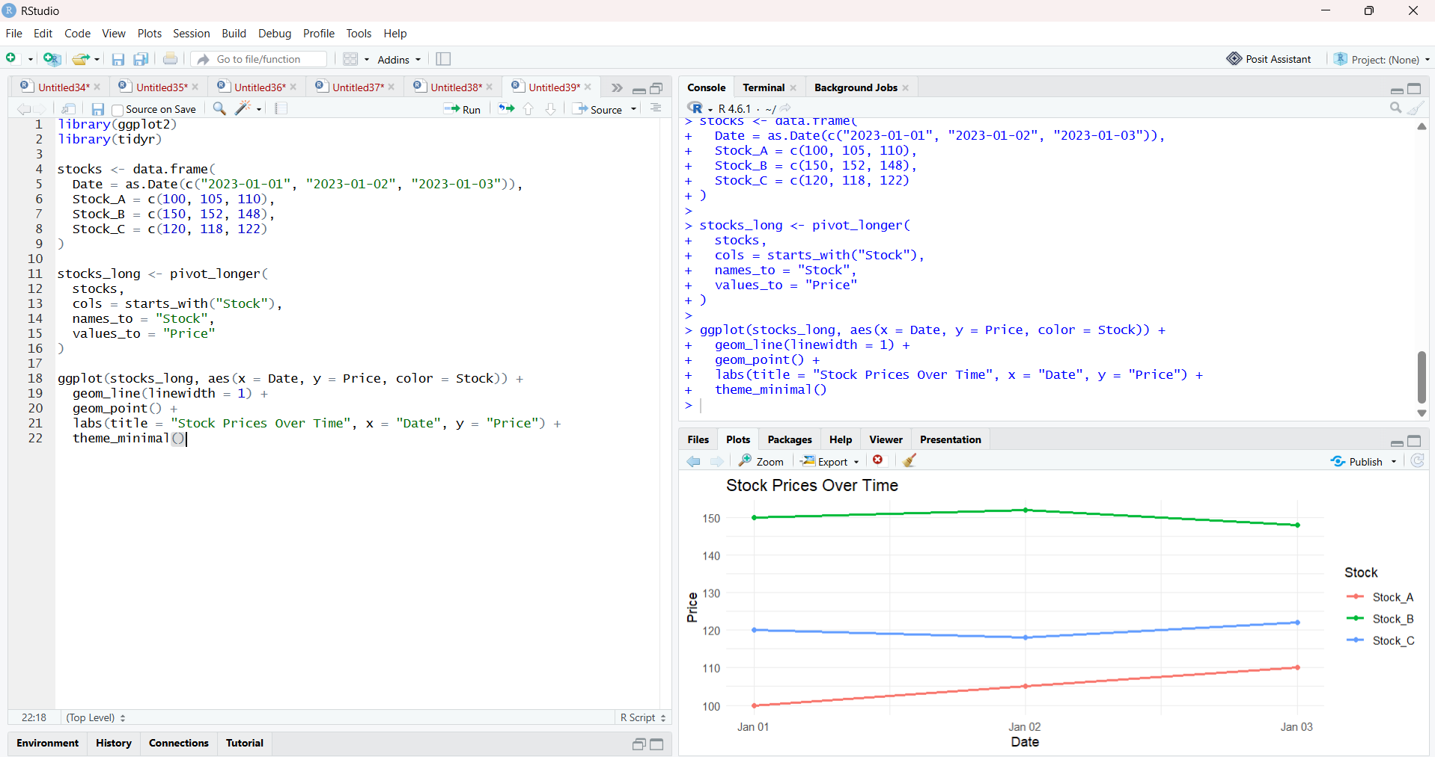

2. Daily percentage change for Stock A
Code:

library(ggplot2)

stocks$Percentage_Change <- c(
NA,
diff(stocks$Stock_A) / head(stocks$Stock_A, -1) * 100
)

ggplot(stocks[-1, ], aes(x = Date, y = Percentage_Change)) +
geom_col(fill = "darkgreen") +
labs(
title = "Daily Percentage Change in Stock A",
x = "Date",
y = "Change (%)"
) +
theme_minimal()

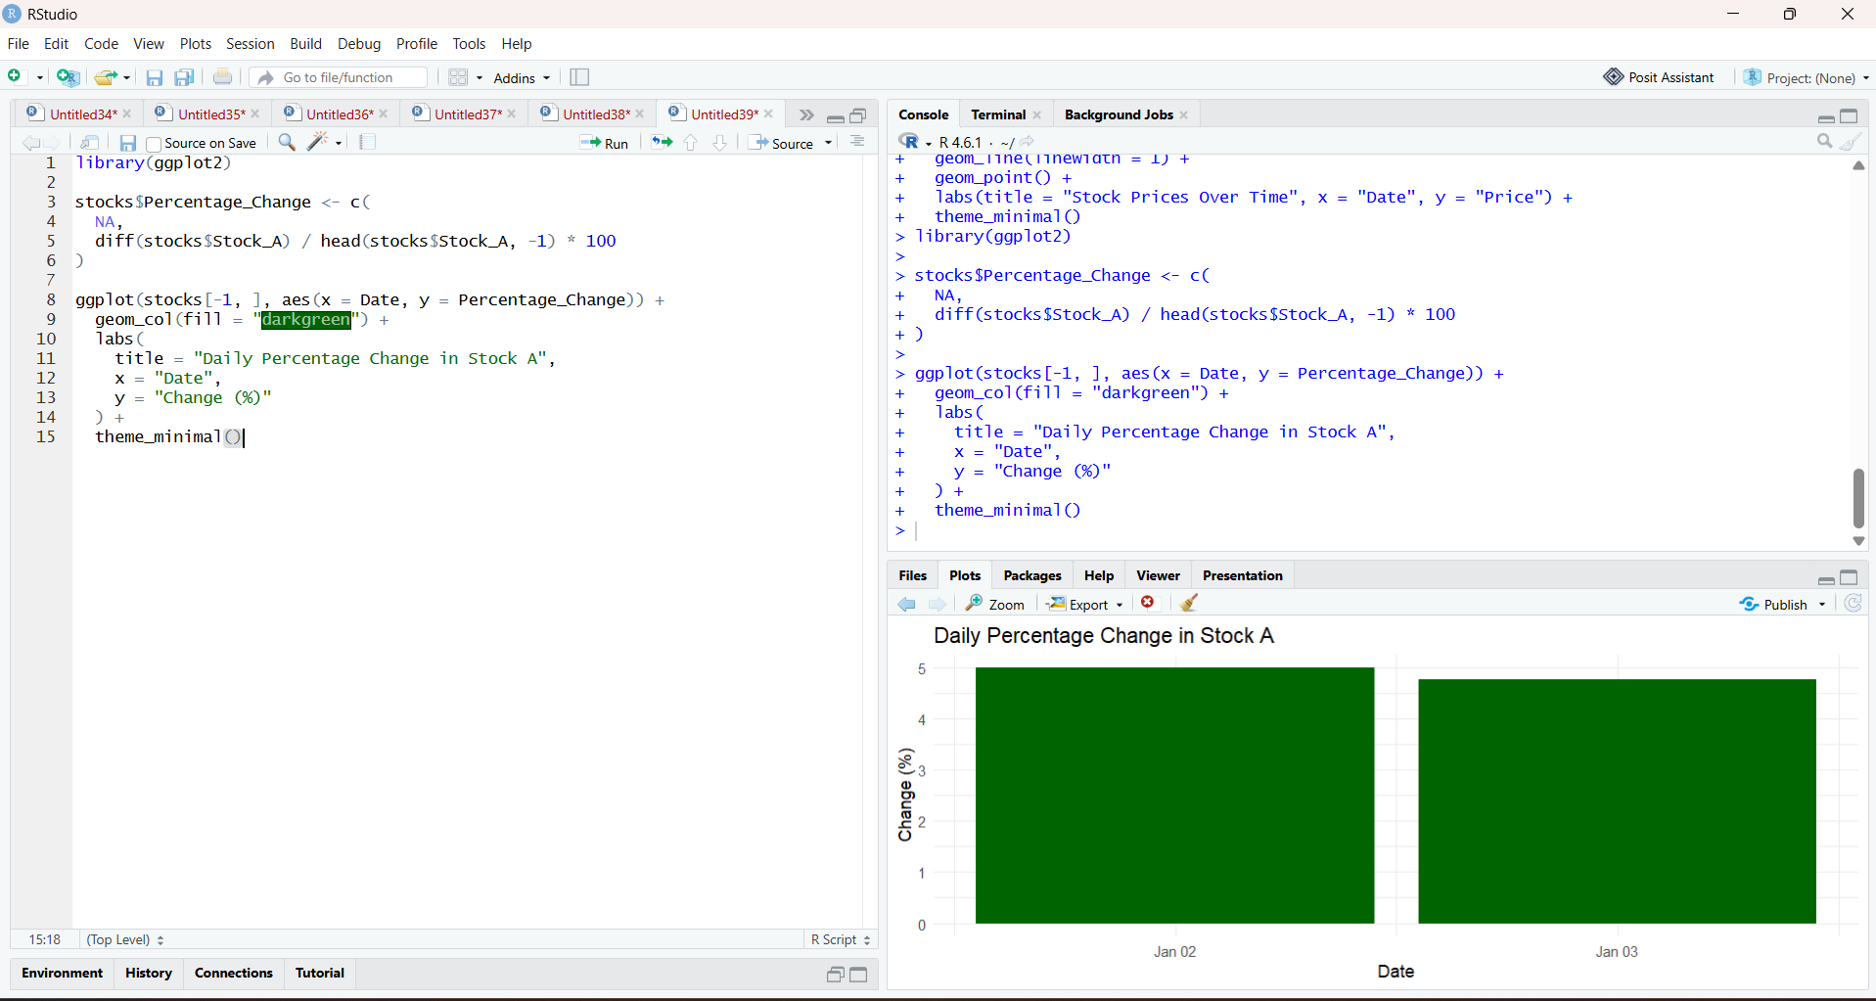

3. Display stock data as a table
Code:

library(knitr)
kable(stocks, caption = "Stock Price Data")

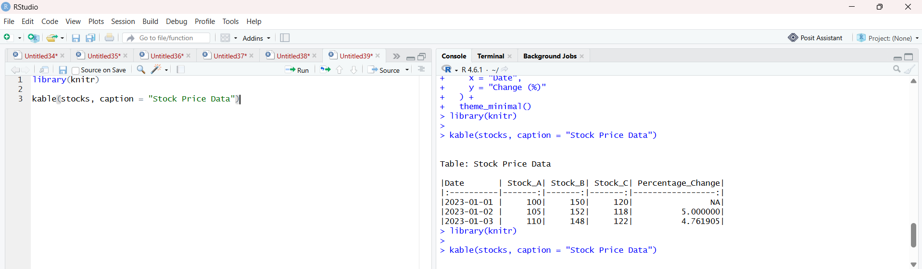

4. Tableau dashboard
Code:

stocks <- data.frame(
Date = as.Date(c("2023-01-01", "2023-01-02", "2023-01-03")),
Stock_A = c(100, 105, 110),
Stock_B = c(150, 152, 148),
Stock_C = c(120, 118, 122)
)

stocks$Change_A <- c(
NA,
diff(stocks$Stock_A) / head(stocks$Stock_A, -1) * 100
)

write.csv(stocks, "Set20_Stock_Prices.csv", row.names = FALSE)

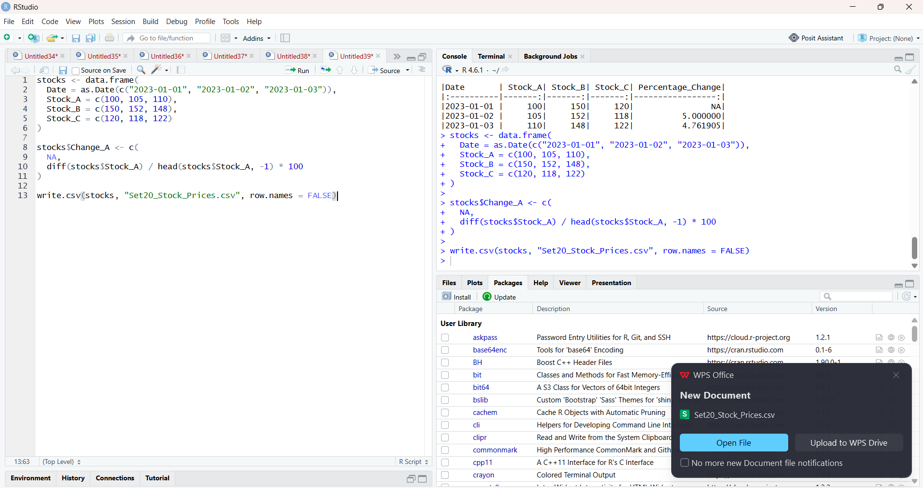
stocks <- data.frame(
Date = as.Date(c("2023-01-01", "2023-01-02", "2023-01-03")),
Stock_A = c(100, 105, 110),
Stock_B = c(150, 152, 148),
Stock_C = c(120, 118, 122)
)

stocks$Change_A <- c(
NA,
diff(stocks$Stock_A) / head(stocks$Stock_A, -1) * 100
)

write.csv(stocks, "Set20_Stock_Prices.csv", row.names = FALSE)

